Aim of the project: We need to derive differentiator set of each mutant based on two different ways and then compare the results. The two ways are:

1. Based on Subsumption (Working on it)
2. Based on Equivalence (Pending)

We will focus on Vt100TerminalModel.java and build the subsumption graph from this class mutants and tests.

LittleDarwin generates 94 mutants for Vt100TerminalModel.java out of which 31 are killed and 18 are subsumed. Below is screenshot of the analysis and the subsumption graph.

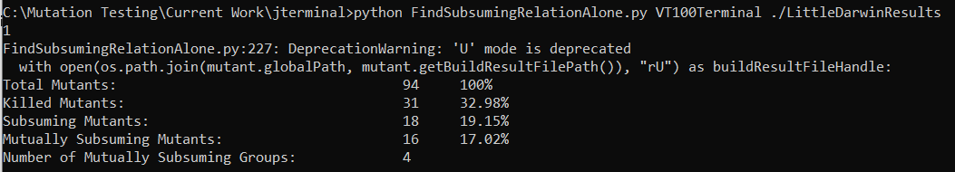

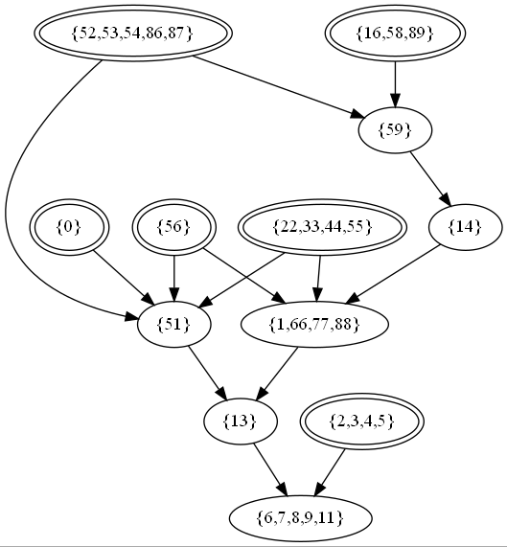

Deriving the DS Based on Subsumption:

1. Get one mutant from each maximal node as Mi: Based on the graph above, we can select 52, 16, 0, 56, 22, 2
2. Run test Tj forevery j on P and Mi for every i. if Output(Mi,Tj) != Output(P,Tj), Tj is in the DS(P,Mi) (Working on it)